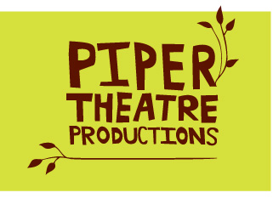

P.O. Box 150613, Brooklyn, New York 11215

breakfastwithmugabe.com

I wish to help build the Off-Broadway debut of Fraser Graces’s Breakfast With Mugabe.

Enclosed is my tax deductible contribution of:

$25 (Nuts and Bolts)
$50 (Bricks and Mortar)
$100 (Cinderblocks)
$500 (Vaulted Arch: Includes an opportunity to meet the cast and a signed poster.)
$1,000 (Keystone: Includes 2 tickets to a performance, a meeting with the cast and a signed poster.)
$5,000 (Architect: Includes 2 tickets to a performance, an invitation to the opening night reception, a meeting with the cast and a signed poster.)
Other

My information:
Name
Street
City/State/Zip
E-mail
Phone

Checks should made to Piper Theatre Productions.

Please write “Mugabe” in the subject area of your check so that this donation may be tracked for bookkeeping purposes.
Piper’s address is:
Piper Theatre Productions
P.O. Box 150613
Brooklyn, NY 11215

Piper Theatre Company is a 501©3. All gifts are tax deductible to the full extent of the law.

